**Client-Side App Rubric** <https://github.com/denisecase/pbl-lifeline-links>

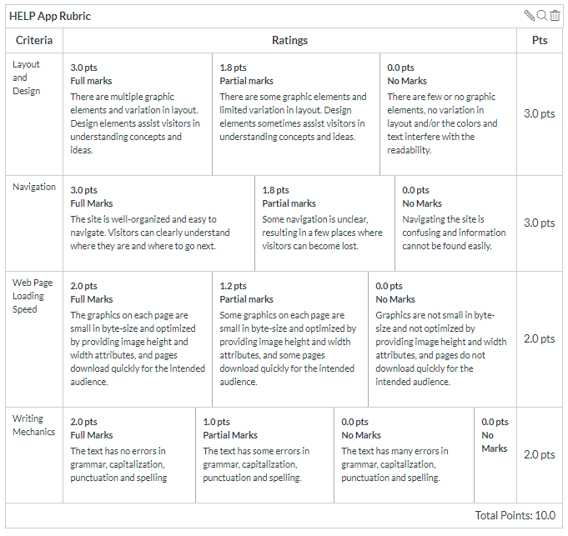

**Team reviewed:** Group 04-01

**Link to the web site**: https://chinmayi98.github.io/help-app/

**Layout and Design**

Score: 3

Comments: Layout and design is fine. There are clear sections indicating what information belongs where, and they are separated in a way that is intuitive.

**Navigation**

Score: 1.8

Comments: Navigation is easy to understand, but once you click out to the history page, it is impossible to return to the home/index page. You either have to go back to the link provided or return to the previous page by your browser, since all of the ‘links’ on the nav actually just lead you to a certain part of the current page.

**Loading Speed:**

Score: 1.2

Comments: Some images are slow to load, and the pricing guidelines takes an abnormally long time to load when you are scrolling. You can only see a portion of it for a good 2 to 5 seconds before it finally shows up.

**Writing Mechanics:**

Score: 1

Comments: Mission statement is a run-on sentence. Some commas unnecessary, and some needed in places they are not. For example, “The AutoAleert help button worn on the outside of the subcriber’s clothing, detects a fall by the velocity of the swing of this button during the fall” needs a comma between ‘button’ and ‘worn.’

**General remarks:** This website is identical to Group 04-02, so that is why remarks are identical on both reports.

**Review performed by:** Group 5

**Date and time performed:** 12/3/2019 1:03 pm